**PROJECT REPORT**

**Computer Organization & Assembly Language**

*(*CEL-324*)*



**BS (CS)-3A**

**Group Members**

**BEENISH HANIF (02-134212-012 )**

**TOOBA NAUSHEEN (02-134212-023)**

**ANUSHA MATEEN(02-134212-087)**

**Submitted to:**

**MISS SABA NAEEM**

**BAHRIA UNIVERSITY KARACHI CAMPUS**

*Department of Computer Science*

**Table of Content**

1 ABSTRACT…………………………..……………………………………………..……....2

2 INTRODUCTION…………………..………………………………………………………2

3 LITERATURE REVIEW………………………..……….………………………………..3

**4 METHADOLOGY……………………………….………………………………….……...3**

**5 CODE.…..…………………………………...………………………………………….…...4**

**6 CONCLUSIONS..………………………….……………………………………………...11**

**7 REFERENCES……………………..…….………………………………………………..11**

**ABSTRACT:**

Customer satisfaction is the key to success for any business. In a

restaurant, the traditional hand-waving method for calling services is

inefficient often leading to many complaints. The Restaurant Management

System increases operational efficiency through use of an internal wired

communications system. The communications system increases customer

satisfaction by leaving a system at each table which the customer can use to

request for a server. This system allows managers and owners to easily monitor

restaurant functions and employee progress.

In many popular restaurants, waiters/waitresses tend to miss out

on tables or customers’ calls during busy hours potentially decreasing ones

clientele. While this is an ongoing issue, there is still no product that

drastically improves the communication between the servers and the

customers in the current market. Hence, the goal is to design a system in

which the customers can call their servers easily and help the restaurant

increase overall efficiency.

Customer satisfaction is the key to success for any business. In a restaurant, the traditional hand-waving method for calling services is inefficient often leading to many complaints. The Restaurant Management System increases operational efficiency through use of a communications system. The communication system increases customer satisfaction by leaving a system at restaurant which the customer can use to request for an order. This system allows managers and owners to easily monitor restaurant functions and food delivery progress. In many popular restaurants, waiters/waitresses tend to miss out on tables or customers calls during busy hours potentially decreasing ones clientele. While this is an ongoing issue, there is still no product that drastically improves the communication between the servers and the customers in the current market. Hence, the goal is to design a system in which the customers can call their servers easily and help the restaurant increase overall efficiency.

**INTRODUCTION:**

**“RESTAURANT MANAGEMENT SYSTEM”**  is the system to manage the restaurant business. The main point of developing this system is to help restaurant administrator manage the restaurant business and help customer for online ordering and reserve table. The project is developed because many restaurants have a lot of difficulty to manage the business such as customer ordering and reservation table. By using manual customer ordering is difficult to waiter keep the correct menu info. So online restaurant management system will develop to help the restaurant administrator to manage restaurant management and for customer make their online ordering and reservation table. Other than that, this project is to upgrade the manual system and make the business easily to access and systematic.

**LITERATURE REVIEW:**

The perspectives of organizational, marketing and strategic management theories provide a reliable theoretical groundwork to understand the important managerial aspects of menu. For instance, organization theory explicitly emphasizes the influence of external environment both on the decisions of firm managers and the survival of ﬁrms on the long run.

Planning and operating menus in a restaurant context involve considering external factors such as customers, rivals, and vendors that have a great potential in creating uncertainty, diversity and volatility in the restaurants' immediate business environment. Complementing this view, marketing theory recognizes the importance of identifying the needs and expectations of customers and developing and improving products and service perfectly ﬁt to those needs and expectations. Additionally, pricing, promoting and distributing the products and services should also be consistent with the customers' needs and expectations on the one hand, and with the ﬁrm's objectives on the other hand. Thus, in the restaurant context, it is imperative that menu as the food and beverage combinations offered by a restaurant reflects the expectations and needs of customers. Moreover, managing menus involves planning, pricing, designing, dis-tributing and promotional decisions which are also the main issues. The concept of restaurant order management system, since it is android application, keep everything as simple as possible. The project consists in an application that can be used by employees in a restaurant to handle the clients, their orders and can help them easily find free tables.

**METHADOLOGY:**

The Restaurant Management System Project in assembly language is developed using Emu8086.Emu8086 combines an advanced source editor, assembler, disassemble and software emulator (Virtual PC) with debugger. It compiles the source code and executes it on emulator step by step. Visual interface is very easy to work with. It is a fully functional project based on assembly language. It includes every component that a restaurant management system must have. It includes number of features that let users keep track of anything from placing food orders to reserving tables. This system is completely obvious. The approach is completely transparent, identical to real-world situations, and well-implemented. The consumer will choose something from the menu that is displayed on the screen. Additionally, customers have the option of eating in or delivering the food to their location. The menu and serving size for the ordered meal are listed by the system. The user only needs to take the action of looking at the menu here. The Restaurant Management System Project contain of user, when the software runs, the menus that are currently accessible are listed and shown. Once a certain item is completed, the system will print a message and show the menu so you may order something else. The customer may examine the ordered meal, the total cost, the table number, and the amount of each item. If there are no tables available at that time, a notice indicating “table finished” will appear on the output screen. The output screen will display the message "Wrong input" if the user enters the wrong number while selecting from the menu. Introducing a brand-new assembly language project for an online restaurant management system that contains all the necessary elements for monitoring operations as well as a reliable learning resource.

**CODE:**

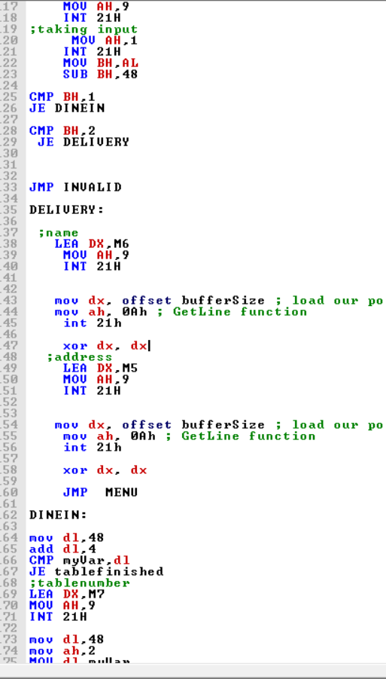

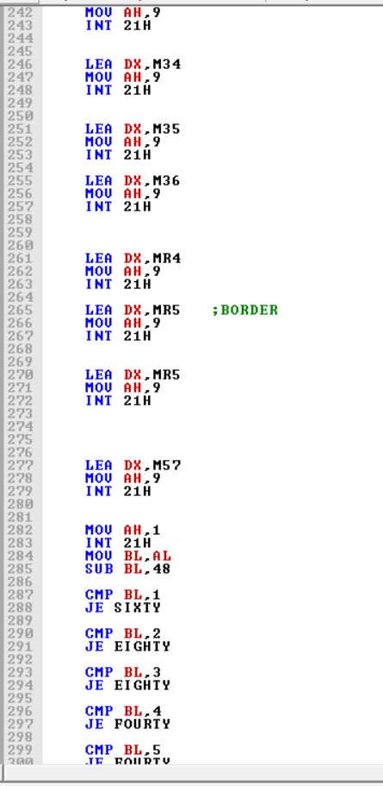

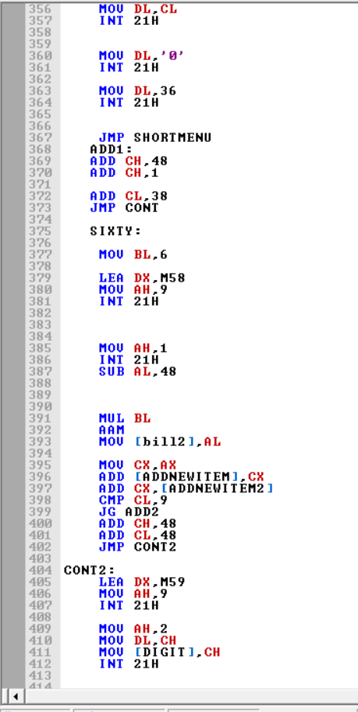

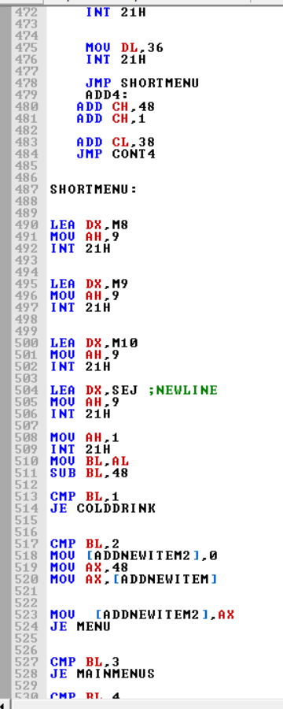

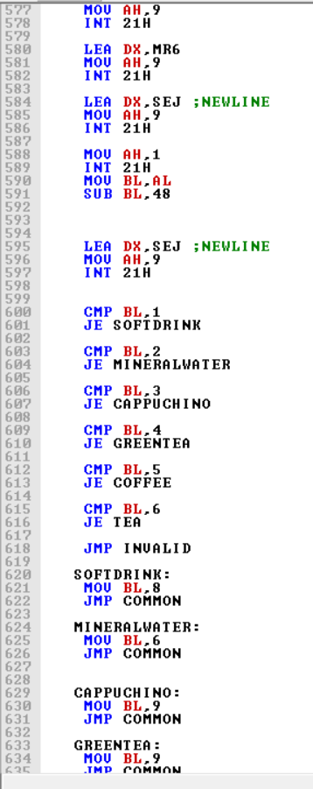

**CONCLUSION:**

The purpose of the restaurant management system is to improve worker efficiency and to maximize profit margin of restaurant owners by providing better service. The proposed solution is dedicated to the efficient management of restaurants. Using this system, customers can order their food without any obligation. The system will provide maximum security and reliability and it is designed in a way to meet the needs of the customers. With the use of assembly language and the emu8086 emulator, we have created a program that allows customers to place orders, track their orders, and make payments all within the system. This will not only increase the efficiency of the restaurant but also provide a better customer experience.

**REFERENCES:**

* William Stallings, Computer Organization and. Architecture, 10th Edition, Prentice Hall, 2016
* Computer Systems: A Programmer's Perspective, 3/E, Randal E. Bryant and David R.O' Hallaron
* www.google.com
* [www.youtube.com](http://www.youtube.com)
* www.wikepedia.com